Hackerrank username : prasetyaganang9

Create Structure folder for each case :

**SQL**

1. **Basic Select**
2. SQL->Basic Select-> Revising The Select Query I ( SQL/1 Basic Select/Revising The Select Query I.sql ) ->

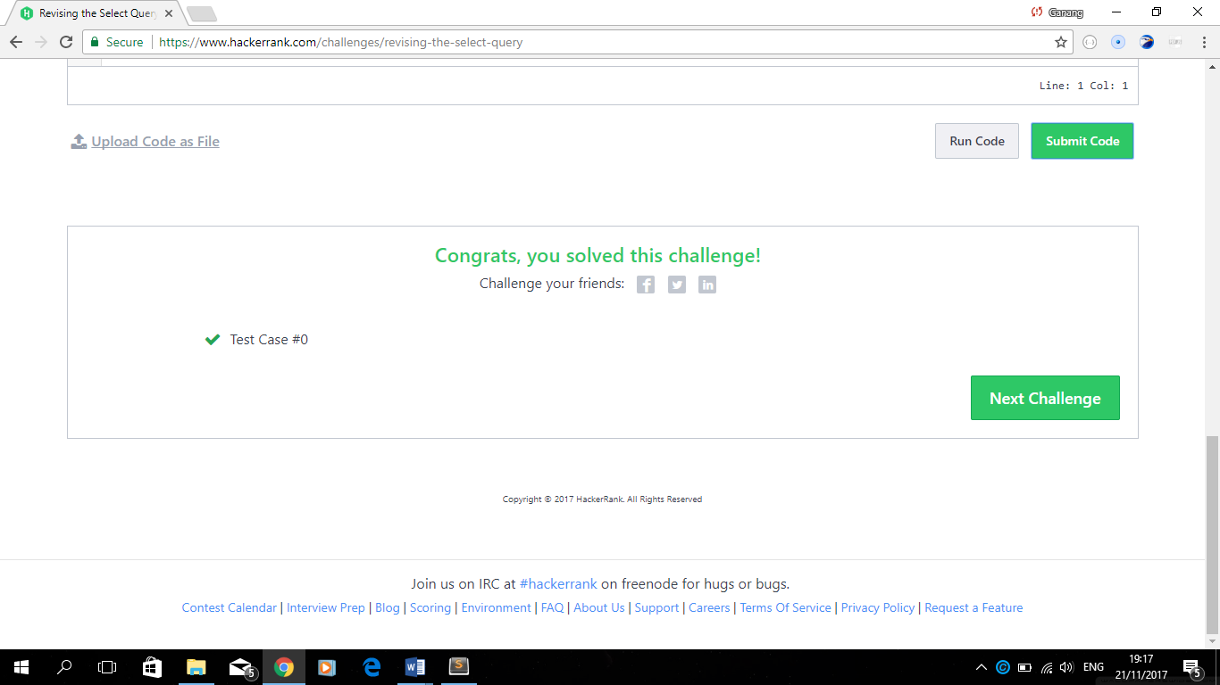

1. SQL->Basic Select-> Revising The Select Query II ( SQL/1 Basic Select/Revising The Select Query II.sql ) ->

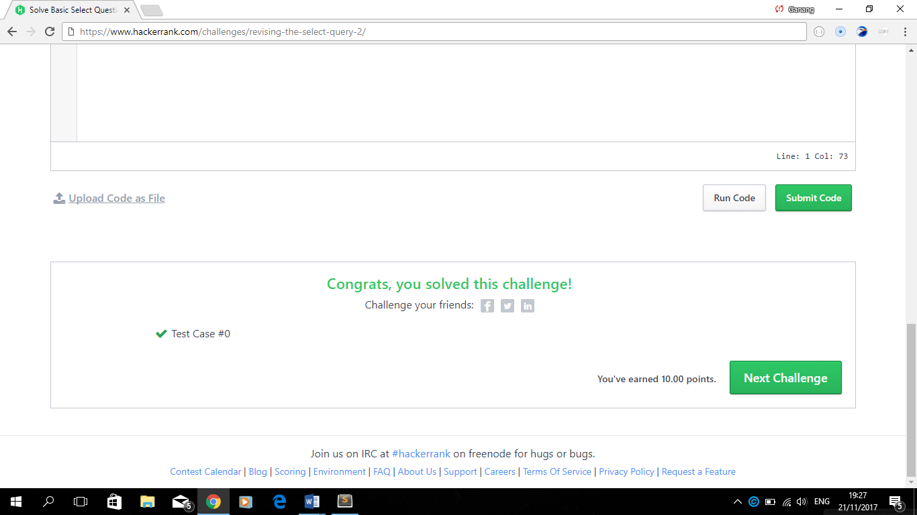

1. SQL->Basic Select-> Select All ( SQL/1 Basic Select/Select All.sql ) ->



1. SQL->Basic Select-> Select By Id ( SQL/1 Basic Select/Select By Id.sql ) ->



1. SQL->Basic Select-> Japanese Cities Attributes ( SQL/1 Basic Select/Japanese Cities Attributes.sql)->



1. SQL->Basic Select-> Japanese City Names ( SQL/1 Basic Select/Japanese City Names.sql)->



1. SQL->Basic Select->Weather Observation Station 1 ( SQL/1 Basic Select/Weather Observation Station 1.sql)->



1. SQL->Basic Select->Weather Observation Station 3 ( SQL/1 Basic Select/Weather Observation Station 3.sql )->



1. SQL->Basic Select->Weather Observation Station 4 ( SQL/1 Basic Select/Weather Observation Station 4.sql ) ->



1. SQL->Basic Select->Weather Observation Station 5 ( SQL/1 Basic Select/Weather Observation Station 5.sql ) ->

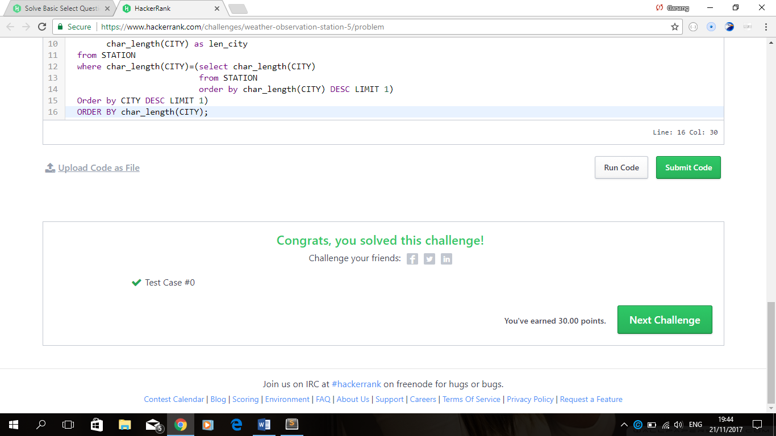

1. SQL->Basic Select->Weather Observation Station 6 ( SQL/1 Basic Select/Weather Observation Station 6.sql ) ->



1. SQL->Basic Select->Weather Observation Station 7 ( SQL/1 Basic Select/Weather Observation Station 7.sql ) ->



1. SQL->Basic Select->Weather Observation Station 8 ( SQL/1 Basic Select/Weather Observation Station 8.sql ) ->



1. SQL->Basic Select->Weather Observation Station 9 ( SQL/1 Basic Select/Weather Observation Station 9.sql ) ->



1. SQL->Basic Select-> Weather Observation Station 10 ( SQL/1 Basic Select/Weather Observation Station 10.sql )->



1. SQL->Basic Select-> Weather Observation Station 11 ( SQL/1 Basic Select/Weather Observation Station 11.sql )



1. SQL->Basic Select->Weather Observation Station 12 ( SQL/1 Basic Select/Weather Observation Station 12.sql )



1. SQL->Basic Select->Higher Than 75 Marks( SQL/1 Basic Select/Higher Than 75 Marks.sql) ->



1. SQL->Basic Select->Employee Names ( SQL/1 Basic Select/Employee Names.sql ) ->



1. SQL->Basic Select->Employee Salaries ( SQL/1 Basic Select/Employee Salaries.sql ) ->



1. **Advanced Select**
2. SQL->Advanced Select->Type of Triangle ( SQL/2 Advanced Select/Type of Triangle.sql ) ->



1. SQL->Advanced Select-> The PADS ( SQL/2 Advanced Select/The PADS.sql ) ->



1. SQL->Advanced Select->Occupations ( SQL/2 Advanced Select/Occupations.sql ) ->

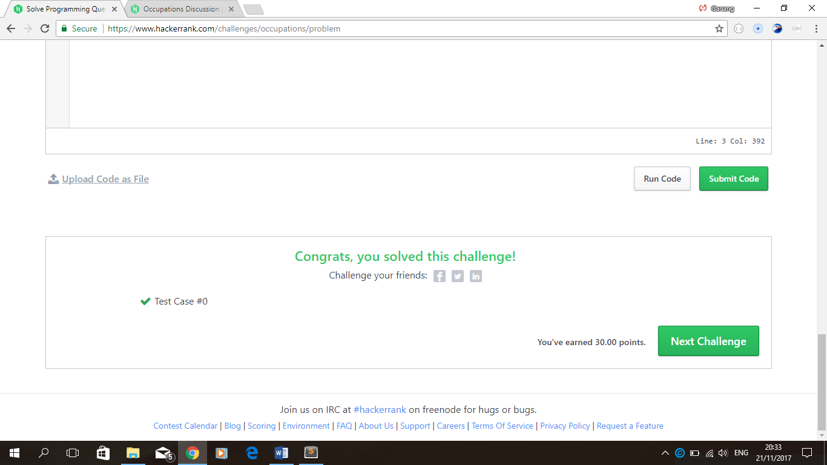

1. SQL->Advanced Select-> Binary Tree Nodes ( SQL/2 Advanced Select/Binary Tree Nodes.sql ) ->

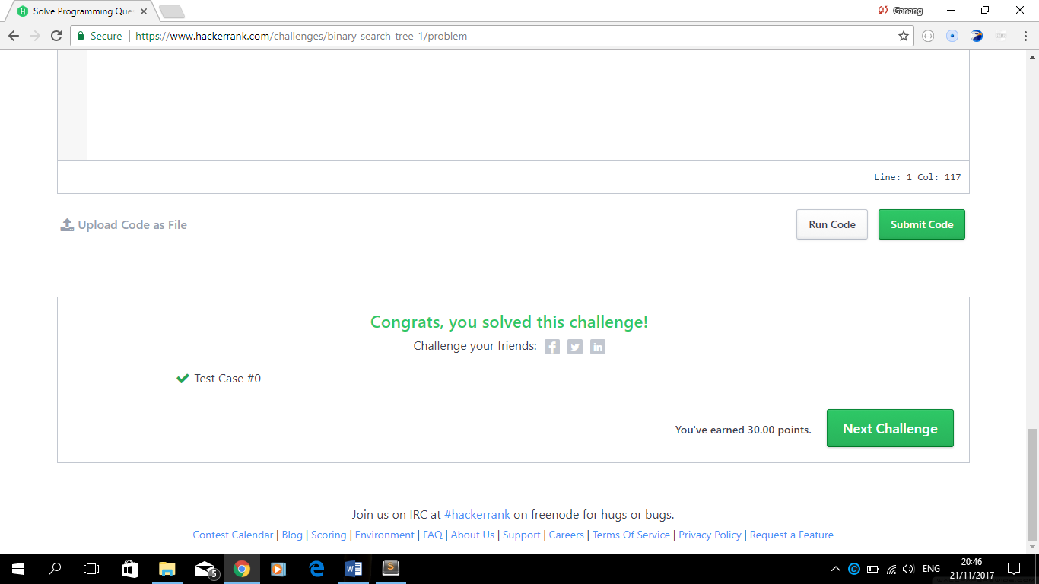

1. SQL->Advanced Select->New Companies ( SQL/2 Advanced Select/New Companies.sql ) ->

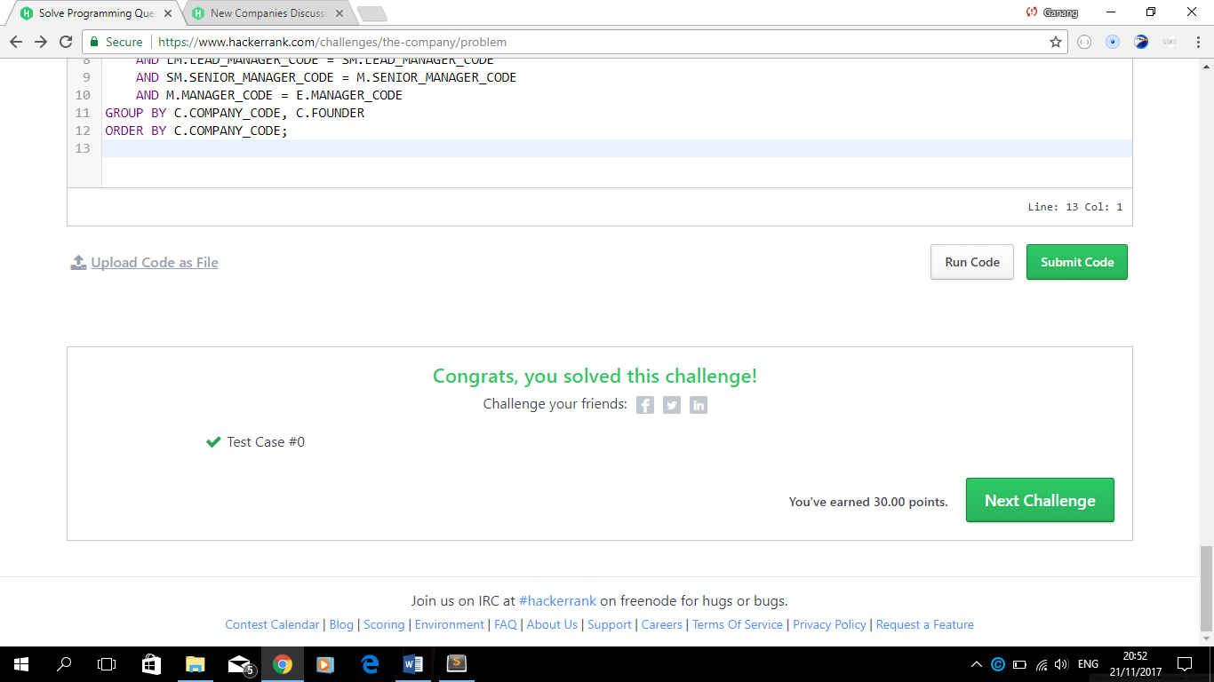

1. **Aggregation**
2. SQL->Aggregation->The Count Function ( SQL/3 Aggregation/The Count Function.sql ) ->

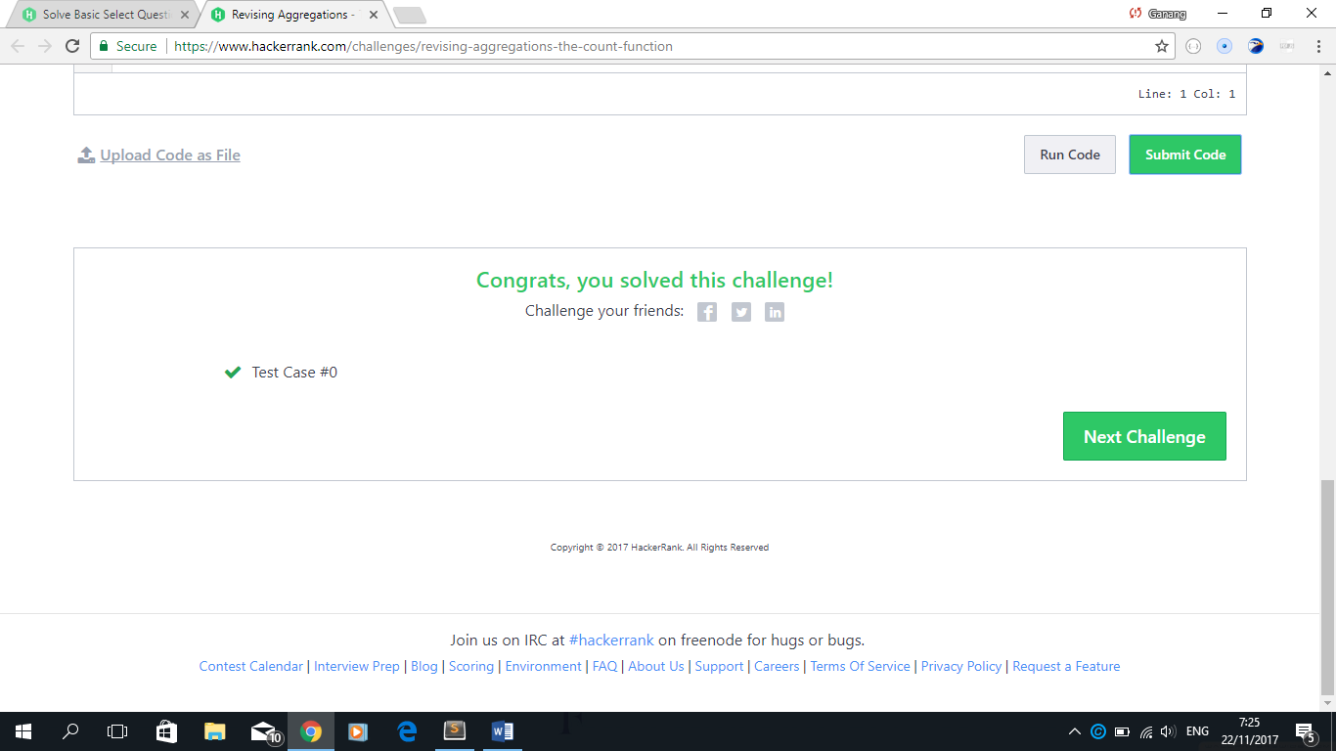

1. SQL->Aggregation->The Sum Function ( SQL/3 Aggregation/The Sum Function.sql ) ->

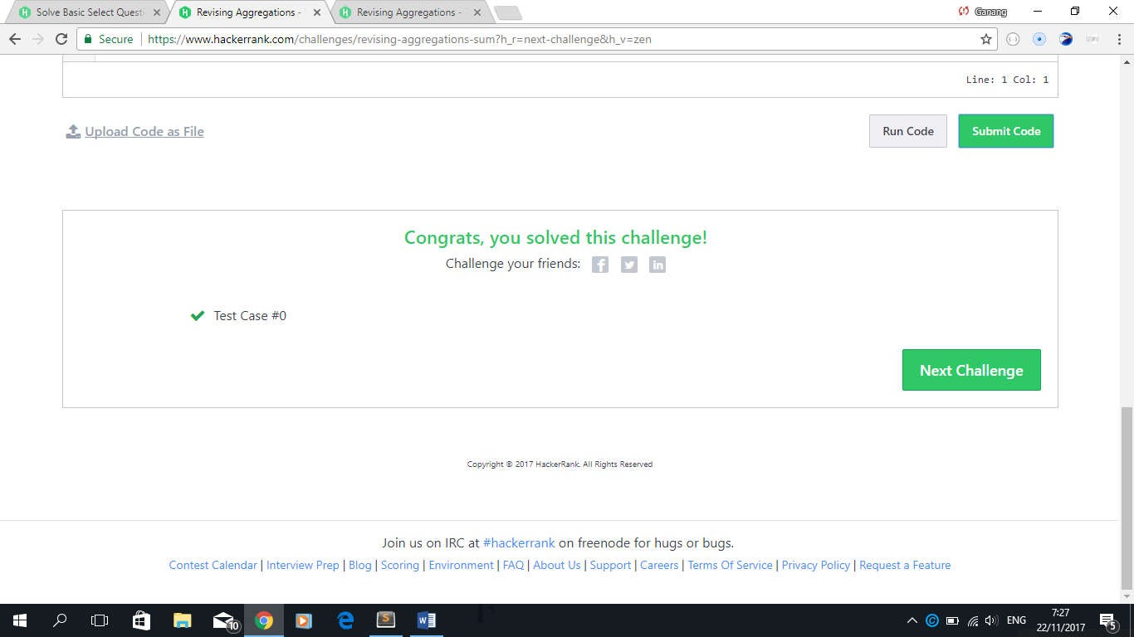

1. SQL->Aggregation-> Averages ( SQL/3 Aggregation/Averages.sql ) ->



1. SQL->Aggregation->Average Population ( SQL/3 Aggregation/Average Population.sql ) ->

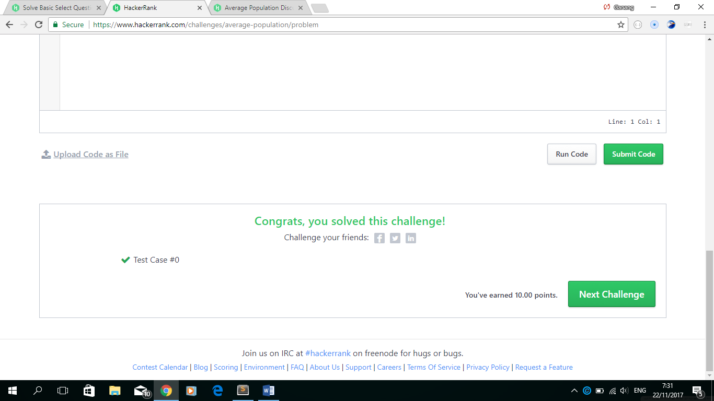

1. SQL->Aggregation->Japan Population ( SQL/3 Aggregation/Japan Population.sql ) ->

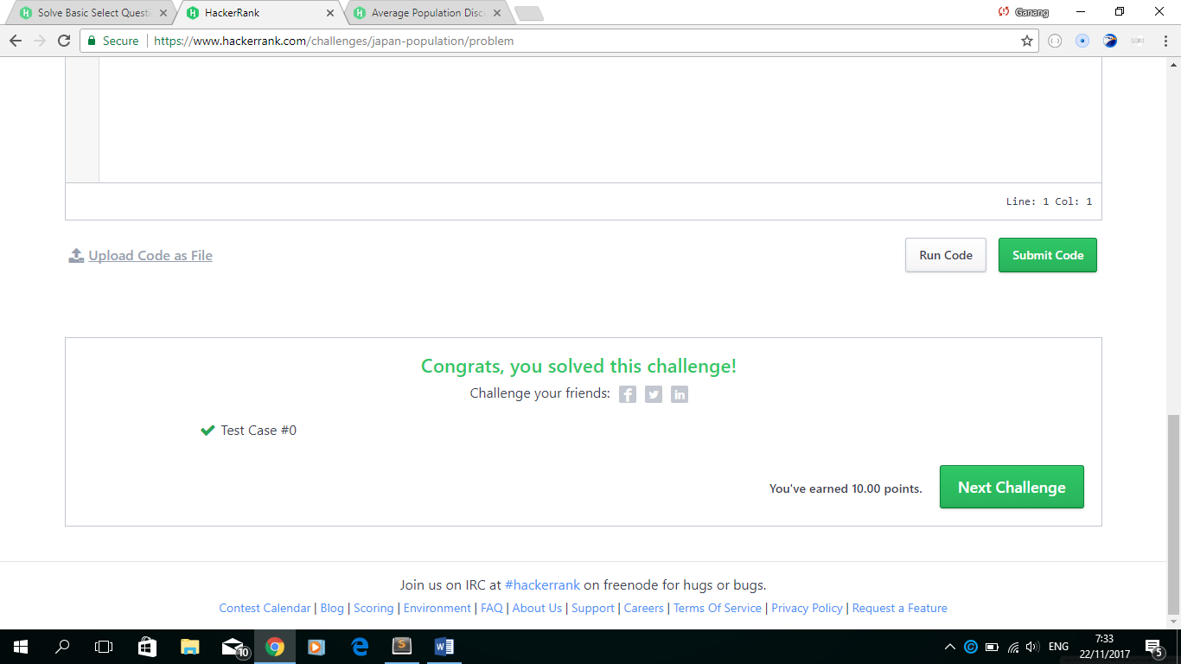

1. SQL->Aggregation->Population Density Diff ( SQL/3 Aggregation/Population Density Diff.sql ) ->

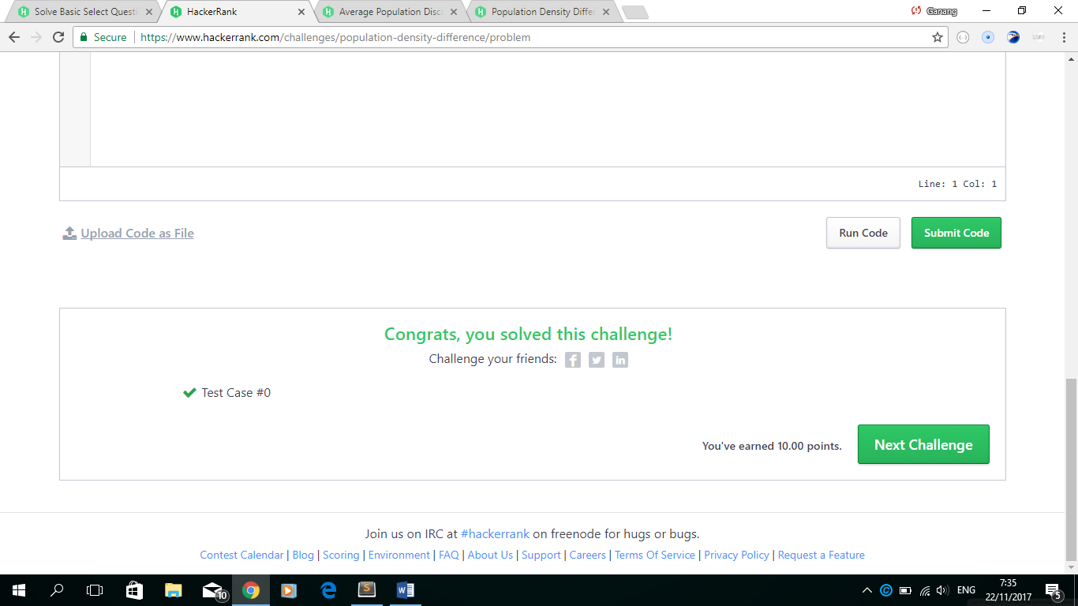

1. SQL->Aggregation->The Blunder ( SQL/3 Aggregation/The Blunder.sql ) ->



1. SQL->Aggregation->Top Earners ( SQL/3 Aggregation/Top Earners.sql ) ->



1. SQL->Aggregation->Weather Observation Station 2 ( SQL/3 Aggregation/Weather Observation Station 2.sql ) ->



1. SQL->Aggregation->Weather Observation Station 13 ( SQL/3 Aggregation/Weather Observation Station 13.sql )->

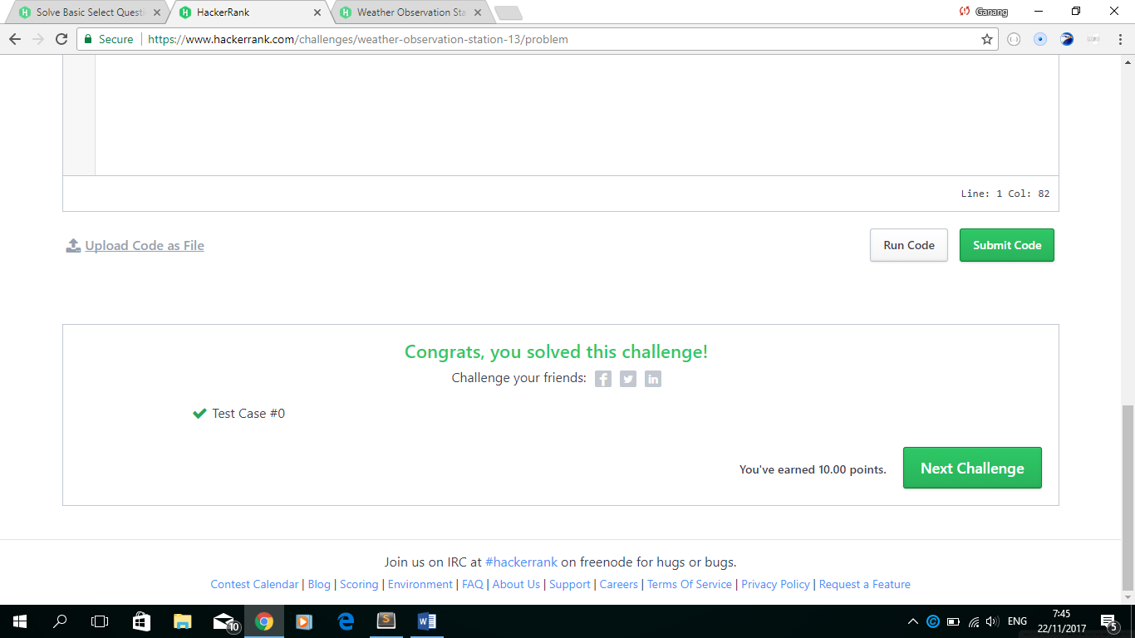

1. SQL->Aggregation->Weather Observation Station 14 ( SQL/3 Aggregation/Weather Observation Station 14.sql )->



1. SQL->Aggregation->Weather Observation Station 15 ( SQL/3 Aggregation/Weather Observation Station 15.sql )->



1. SQL->Aggregation->Weather Observation Station 16 ( SQL/3 Aggregation/Weather Observation Station 16.sql )->



1. SQL->Aggregation->Weather Observation Station 17 ( SQL/3 Aggregation/Weather Observation Station 17.sql )->



1. SQL->Aggregation->Weather Observation Station 18 ( SQL/3 Aggregation/Weather Observation Station 18.sql )->



1. SQL->Aggregation-> Weather Observation Station 19 ( SQL/3 Aggregation/Weather Observation Station 19.sql )->



1. SQL->Aggregation-> Select All ( SQL/3 Aggregation/Weather Observation Station 20.sql )->



1. **Basic Join**
2. SQL->Basic Join->Asian Population ( SQL/4 Basic Join/Asian Population.sql )->

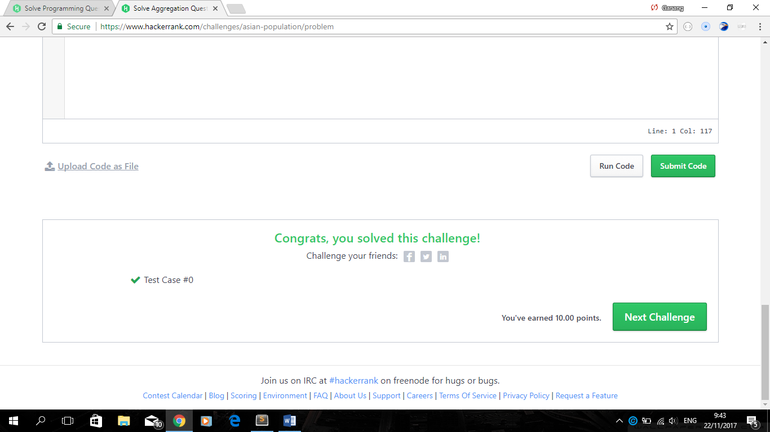

1. SQL->Basic Join->African Cities ( SQL/4 Basic Join/African Cities.sql )->



1. SQL->Basic Join->Average Population of Each Continent ( SQL/4 Basic Join/Average Population of Each Continent.sql )->



1. SQL->Basic Join->The Report ( SQL/4 Basic Join/The Report.sql )->

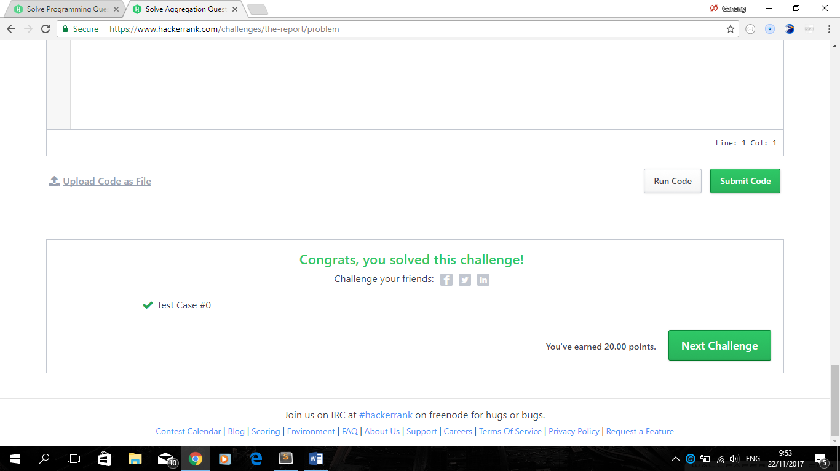

1. SQL->Basic Join->Top Competitors ( SQL/4 Basic Join/Top Competitors.sql )->

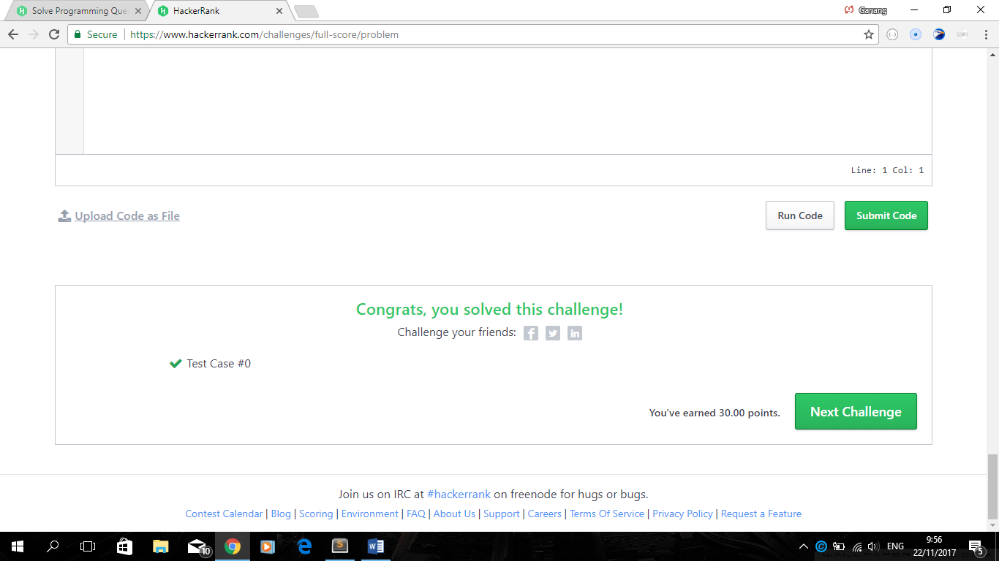

1. SQL->Basic Join->Ollivanders Inventory ( SQL/4 Basic Join/Ollivanders Inventory.sql )->



1. SQL->Basic Join->Challenges ( SQL/4 Basic Join/Challenges.sql )->

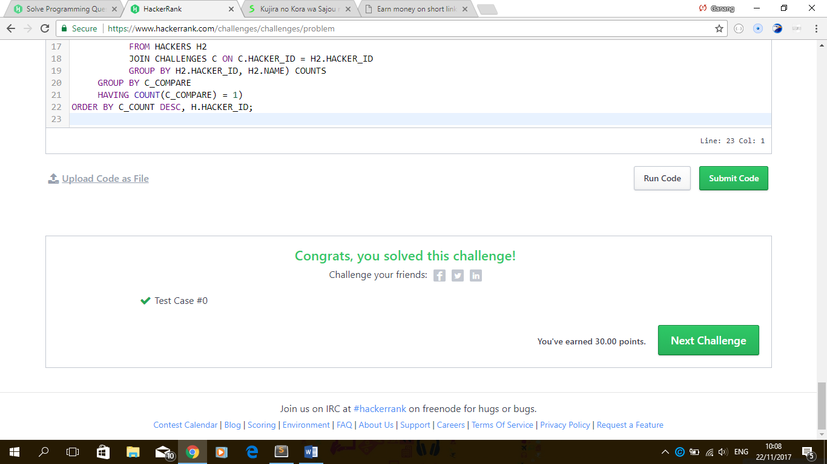

1. SQL->Basic Join->Contest Leaderboard ( SQL/4 Basic Join/Contest Leaderboard.sql )->



1. **Advanced Join**
2. SQL->Advanced Join->Projects ( SQL/5 Advanced Join /Projects.sql )->

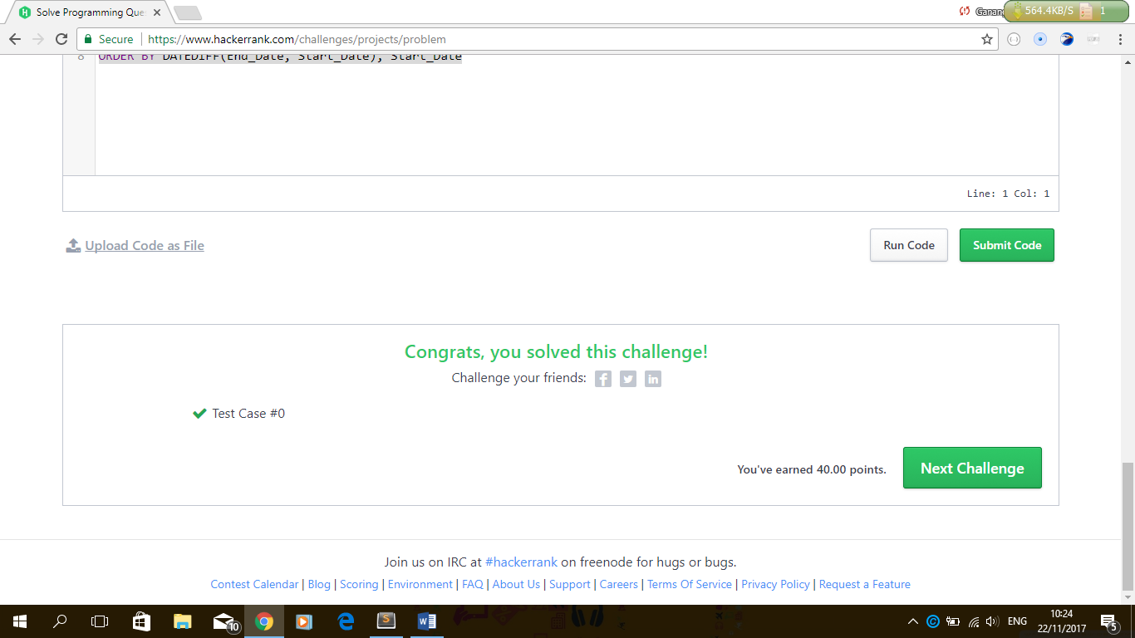

1. SQL->Advanced Join->Placements ( SQL/5 Advanced Join /Placements.sql )->

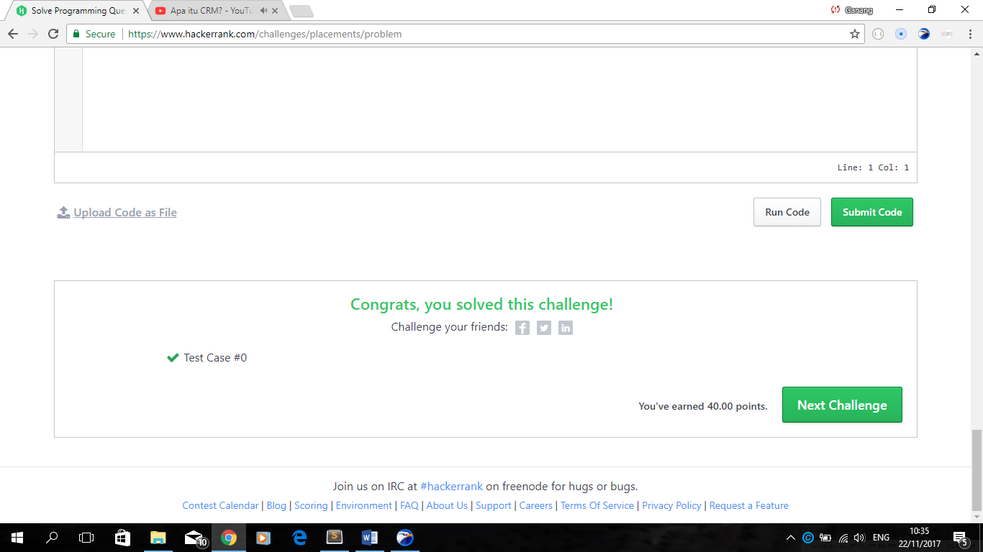

1. SQL->Advanced Join->Symmetric Pairs ( SQL/5 Advanced Join /Symmetric Pairs.sql )->



1. SQL->Advanced Join->Interviews ( SQL/5 Advanced Join /Interviews.sql )->

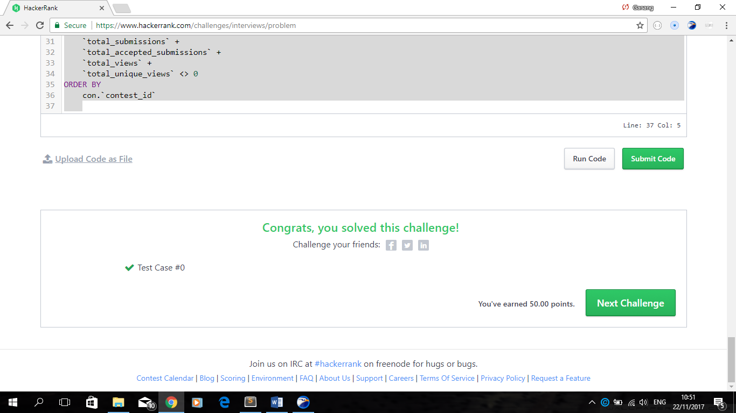

1. SQL->Advanced Join->15 Days of Learning SQL ( SQL/5 Advanced Join /15 Days of Learning SQL.sql )->

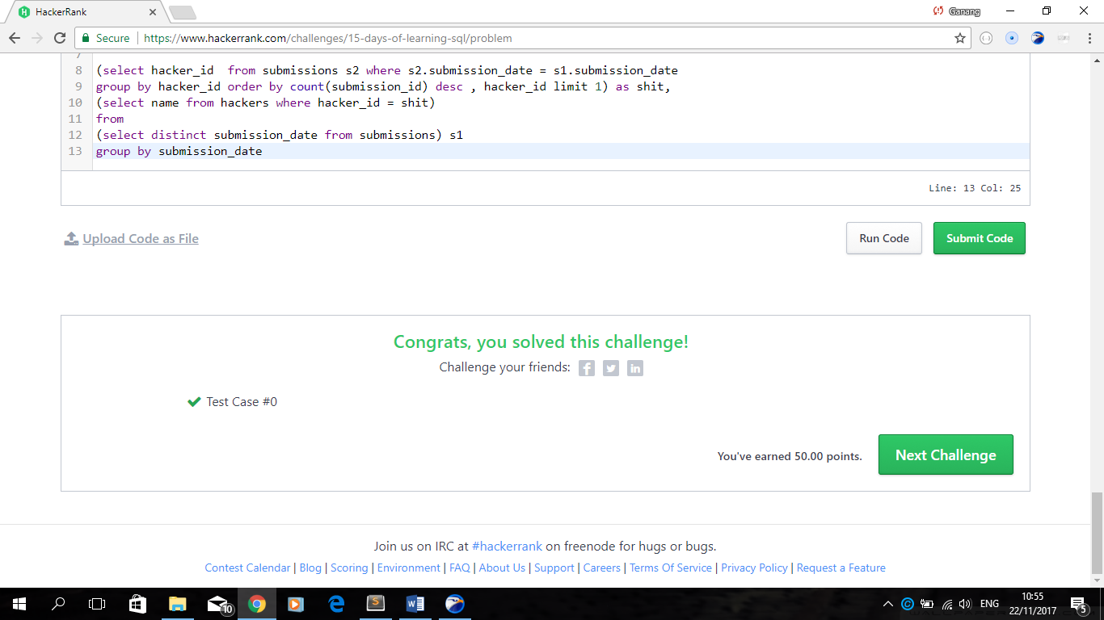

**Algorithms (PHP)**

1. **Warmup**
2. Algorithms(PHP)->Warmup->Solve Me First ( Algorithms (PHP)/1 Warmup /Solve Me First.php )->

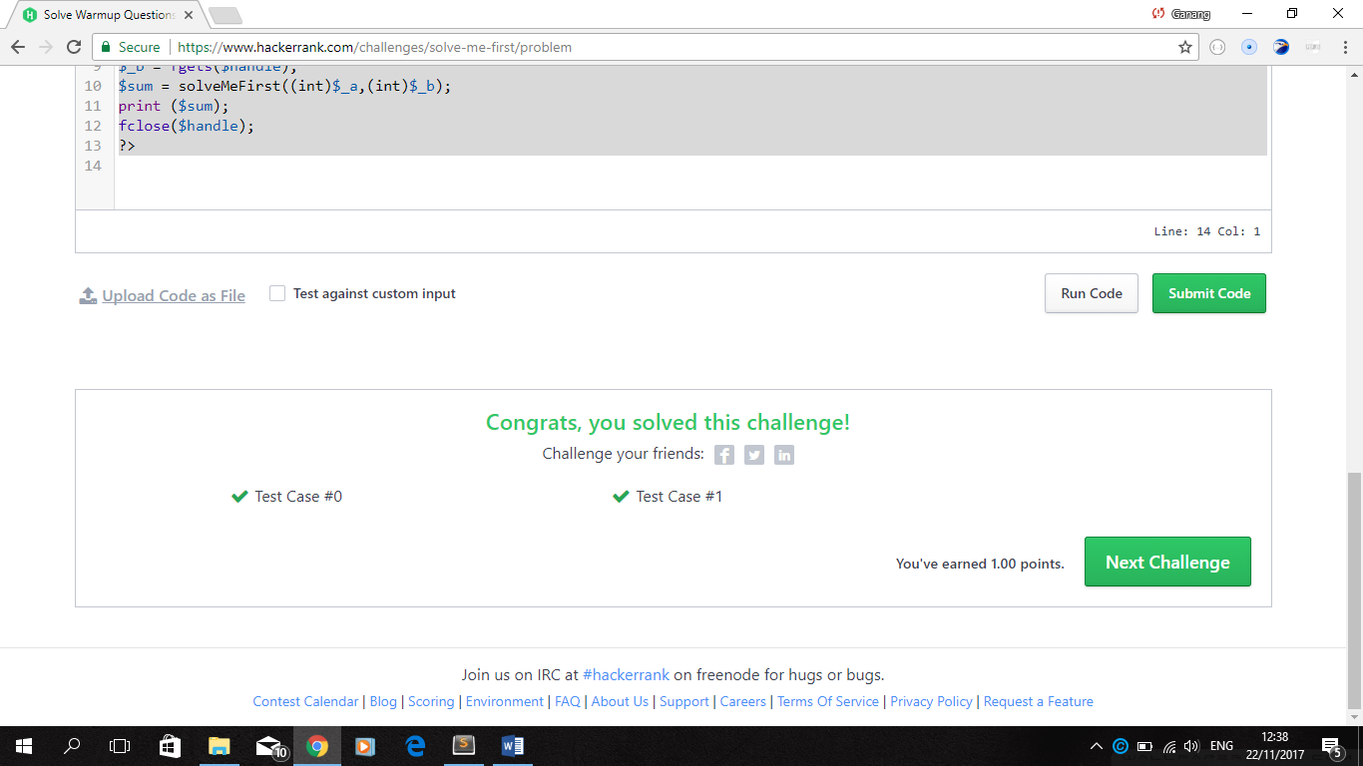

1. Algorithms(PHP)->Warmup->Simple Array Sum ( Algorithms (PHP)/1 Warmup /Simple Array Sum.php )->

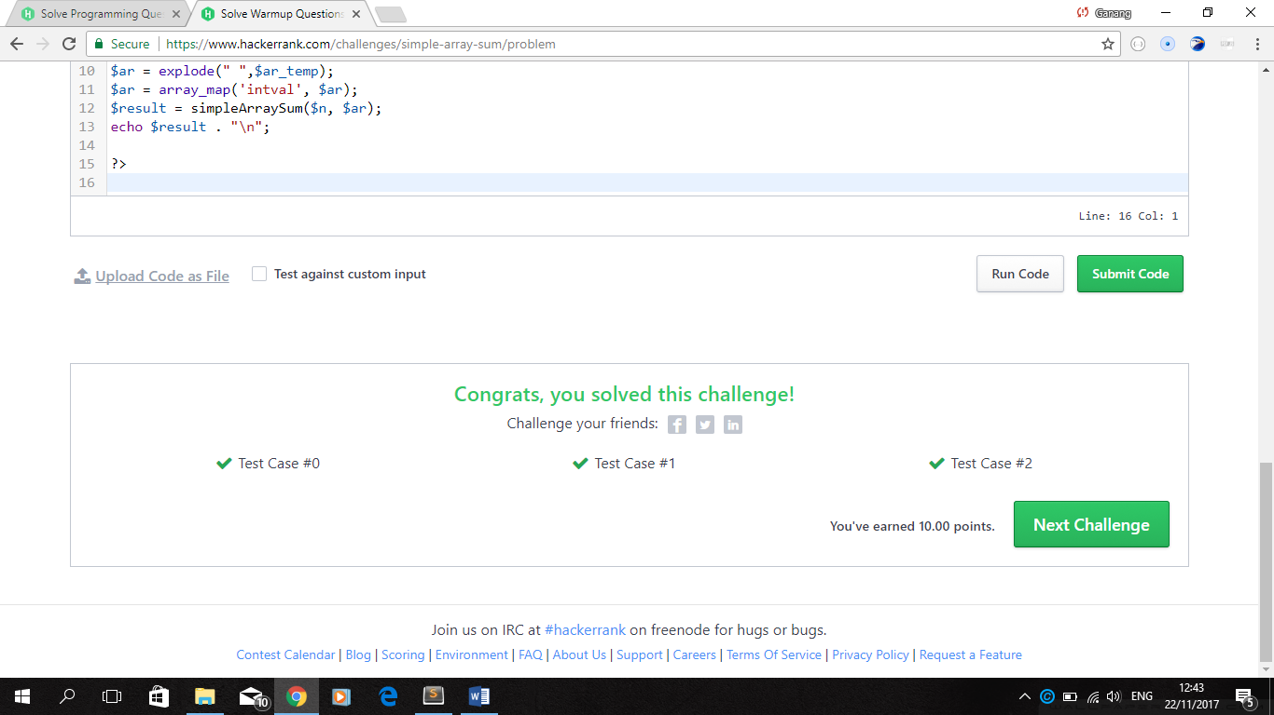

1. Algorithms(PHP)->Warmup->Compare the Triplets ( Algorithms (PHP)/1 Warmup / Compare the Triplets.php )->

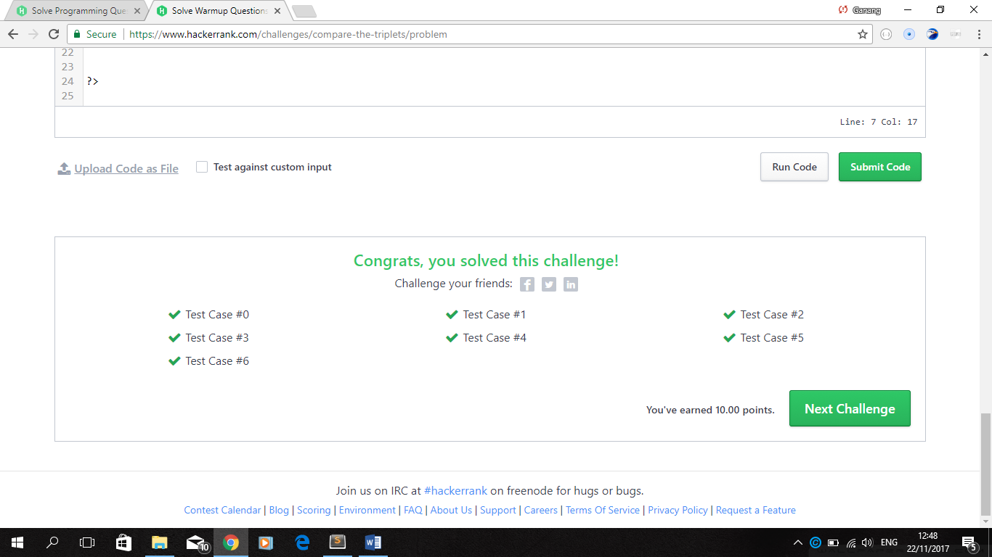

1. Algorithms(PHP)->Warmup->A Very Big Sum ( Algorithms (PHP)/1 Warmup /A Very Big Sum.php )->

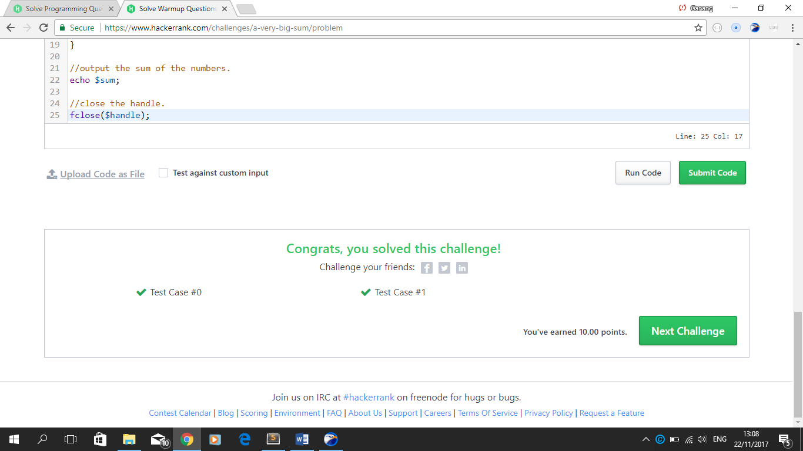

1. Algorithms(PHP)->Warmup->Diagonal Difference ( Algorithms (PHP)/1 Warmup / Diagonal Difference.php )->

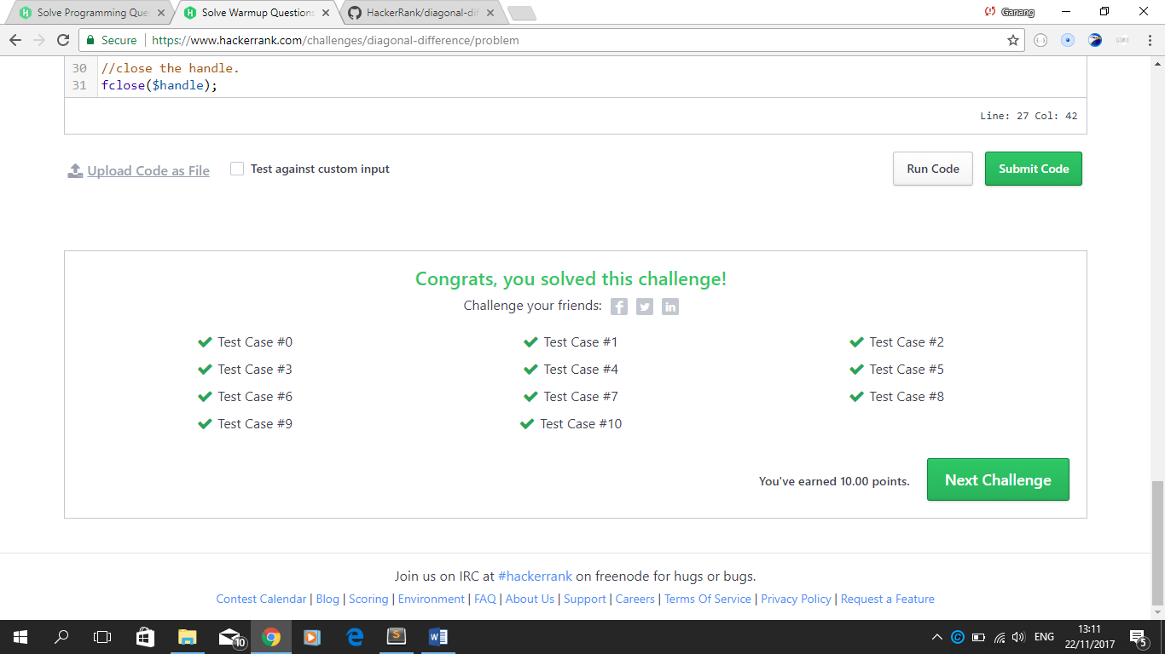

1. Algorithms(PHP)->Warmup->Plus Minus ( Algorithms (PHP)/1 Warmup /Plus Minus.php )->
2. Algorithms(PHP)->Warmup->Solve Me First ( Algorithms (PHP)/1 Warmup /Solve Me First.php )->
3. Algorithms(PHP)->Warmup->Solve Me First ( Algorithms (PHP)/1 Warmup /Solve Me First.php )->
4. Algorithms(PHP)->Warmup->Solve Me First ( Algorithms (PHP)/1 Warmup /Solve Me First.php )->
5. Algorithms(PHP)->Warmup->Solve Me First ( Algorithms (PHP)/1 Warmup /Solve Me First.php )->
6. **Sorting (2 Cases)**
7. **Strings (2 Cases)**
8. **Search (2 Cases)**
9. **Implementation (5 Cases)**